System and Software Architecture Description (SSAD)

Somatis Web and Data Services

Team 3

Name | Roles
Fall 2012
Fei Qu | Project Manager
Jizhou Lu | Life Cycle Planner, Operational Concept Engineer
Xianan Fan | Prototyper
Dian Peng | Architect, Feasibility Engineer
Qiuyang Liu | Requirements Engineer
Jordan Padams | IIV&V
Spring 2013
Jordan Padams | All

Version History
Date | Author | Version | Changes made | Rationale
08/25/05 | PA | 2.0 | - Original template for use with Instructional ICM-Sw v1.0 | - Initial draft for use with Instructional ICM-Sw v1.0
10/11/12 | DP | 2.1 | - Added content for section 1  - Added content for section 2 | - To describe the document goal and status  - To describe the system context and use case.
10/22/12 | DP | 2.2 | - Fix the use case diagram bug  - Add section 2.2  - Enhance the artifact diagram | - Use case error found
10/24/12 | DP | 2.3 | - Update section 1.0  - Update section 2.0 | - Fix bugs in FCP evaluation  - Fix bugs in FCP evaluation
10/31/12 | DP | 2.4 | - Update section 1.0  - Update section 2.0 | - Reduce redundant information  - Fix bugs in the section
11/5/12 | DP | 2.5 | - Update section 2.0 | - Add requirements for security and fix bugs.
11/14/12 | DP | 2.6 | - Update Section 3.0 | - Add content of technology independent design
11/25/12 | DP | 2.7 | - Update Section 4.0  - Update Section 5.0  - Fix bugs | - Add content of technology dependent design  - Add content of architecture pattern ,style and framework  - Fix bugs raised in evaluation
11/26/12 | DP | 3.0 | - Update section 4.0  - Update section 5.0 | - Add content of technology dependent design  - Add content of architecture pattern ,style and framework
11/27/12 | DP | 3.1 | - Update section 4.0  - Update section 5.0 | - Fix bugs in content  - Fix bugs in content
12/7/12 | DP | 3.2 | - Update section 1.0  - Update section 2.0  - Update section 3.0  - Update section 4.0 | - Fix bugs in Bugzilla  - Fix bugs in Bugzilla  - Fix bugs in Bugzilla  - Fix bugs in Bugzilla
12/12/12 | DP | 3.3 | - Update section 3.0  - Update section 4.0 | - Fix bugs in design class  - Fix bugs in design class
12/15/12 | DP | 3.4 | - Update section 3.0  - Update section 4.0 | - Fix bugs pointed out by TA  - Fix bugs pointed out by TA
2/11/13 | JP | 4.0 | - Migrate all applicable information from Architected-Agile template to NDI NCS template. | - Project has transitioned from architected-agile to NDI/NCS process.
2/12/13 | JP | 4.1 | - Create new User Forum use case | - User forum is an OC and requires an accompanying UC

Table of Contents
System and Software Architecture Description (SSAD) i
Version History ii
Table of Contents iv
Table of Tables v
Table of Figures vi
1. Introduction 1
1.1 Purpose of the SSAD 1
1.2 Status of the SSAD 1
2. System Analysis 2
2.1 System Analysis Overview 2
3. NDI/NCS Interoperability Analysis 27
3.1 Introduction 27
3.2 System Structure 28
3.3 Evaluation Summary 28

Table of Tables
Table 1: Actors Summary 3
Table 2: Artifacts and Information Summary 3
Table 3: NDI Products Listing 27
Table 4: NDI Evaluation 28

Table of Figures
Figure 1: System Context Diagram 2
Figure 2: Artifacts and Information Diagram 3
Figure 3: Process Diagram 4

Introduction

Purpose of the SSAD
The purpose of this document is to detail the architecture of the system as elicited through object-oriented analysis and design. The diagrams and use cases detailed below will be used by programmers, maintainers, and stakeholders in an effort to better understand the system context, as well as ensure the system captures stakeholder needs.

Status of the SSAD
Version 4.0 of this document represents a major overhaul from previous versions as the project transitions from the Architected-Agile process framework to NDI-intensive. Portions of the previous version of this document were copied and/or modified as needed (system context, artifacts, etc.) while others were developed from scratch (interoperability analysis).

System Analysis

System Analysis Overview
The primary purpose of Somatis Web And Data Services is to provide the necessary marketing front and infrastructure in and effort to increase Somatis Sensor Solutions’ revenue and profits. The system can be broken down into two prominent components: Web Services and Data Services. The Web Services component will provide a basic website with content and information about the company, social media infusion, user guides/forums, and a sensor configurator “store” that will allow customers to purchase Somatis proprietary sensors. The Data Services component will provide a web interface for the customers to leverage the data gathered from the Somatis-purchased sensors. The Data Services will be included in all sensor purchases.

System Context
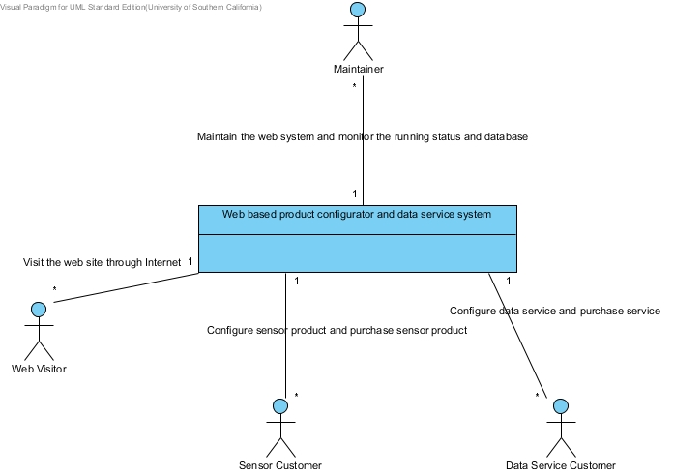Figure 1: System Context Diagram

Table 1: Actors Summary
Actor | Description | Responsibilities
Maintainer | An administrative user of the system that will have permissions to modify all configurations, account information, etc. | - Update web content  - Manage data service users  - Manage data service devices
Sensor Customer | A user that intends to purchase a sensor from Somatis via the sensor configurator. | - Configure the sensor product via the sensor configurator  - Submit purchase to sales team
Data service customer | A data service customer is a user that has purchased a sensor from Somatis, which include a data service, and wishes to access their data via a web interface. | - Review sensor data via data manipulation interface  - Export sensor data  - Configure data manipulation interface
Web Visitor | A user of the website | - Browse the website

Artifacts & Information
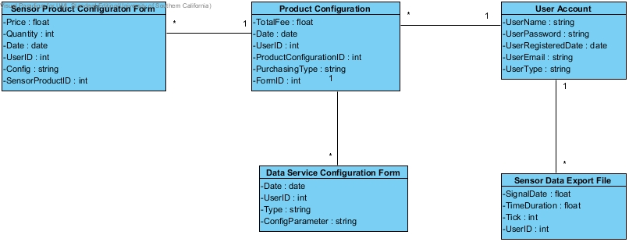Figure 2: Artifacts and Information Diagram
Table 2: Artifacts and Information Summary
Artifact | Purpose
ATF-1:  Sensor product configuration form | This form is used to describe and record the sensor product and it is generated by the user through using configuration module on the web site.
ATF-2:  Data service configuration form | This is form contains the detail information of the data service configuration and it is generated by the user through using data service configuration module on the web site.
ATF-3:  Sensor data export file | This file contains the formatted sensor data and it is generated by the indication of the customer who wishes to have the sensor data locally in the file.
ATF-4:  Product Configuration | This table contains all the historical information of a certain user in terms of its purchasing operation , no matter he/she purchase a sensor product or purchase certain data service.
AFT-5:  User Account | This table contains all the information for a specific user.

Behavior

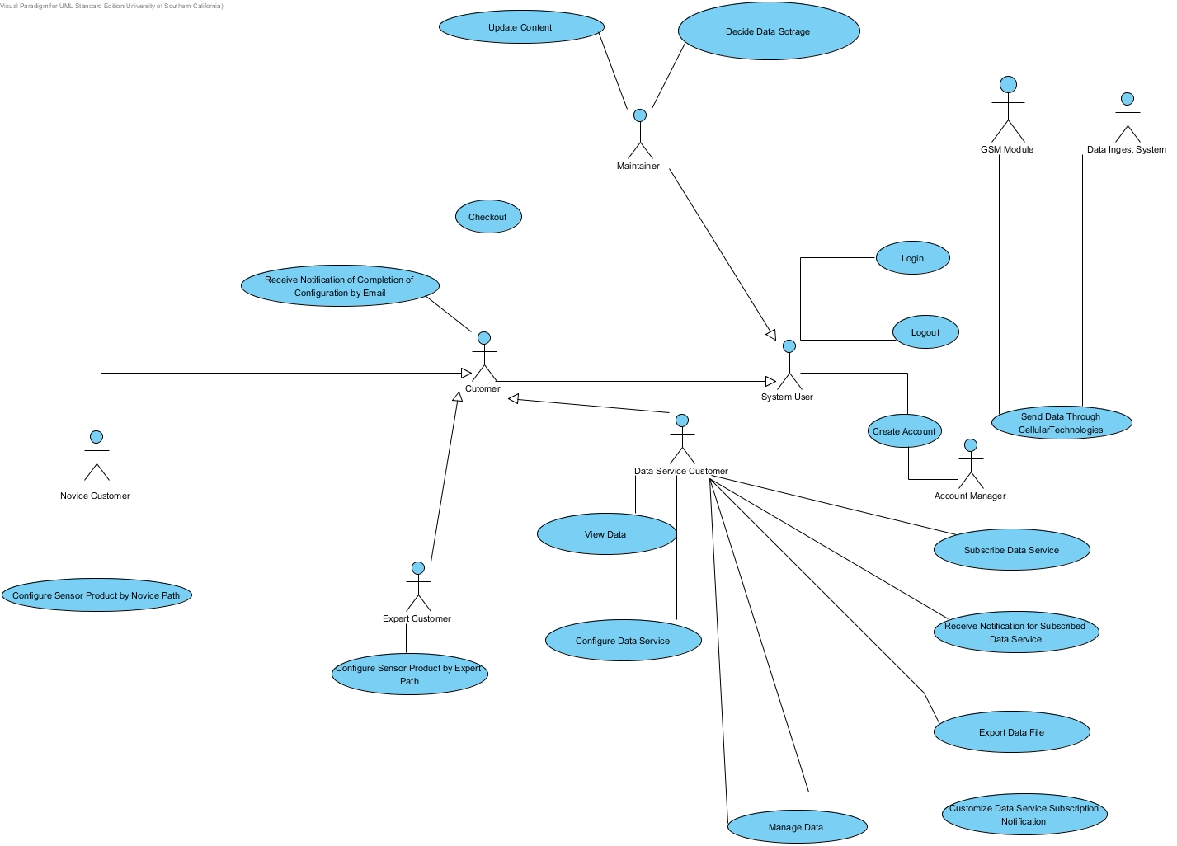Figure 3: Process Diagram

Capability - Login
2.1.3.1.1 Use case 1
Process Description: Login
Identifier | UC-1
Purpose | Determine if a person has the required information to login the system, and assign corresponding system privilege to him/her.
Requirements | WC_1546
Development Risks | Potentially, there exist possible changes in the future about the system privilege which can lead to future modification of the account module.
Pre-conditions | The customer is on the right page provided the login UI.
Post-conditions | The customer is on the specific return page displaying login status

Typical Course of Action – Login: Successfully
Seq# | Actor’s Action | System’s Response
1 | The customer types in the username and password.
2 | The customer clicks the login button.
3 |  | The system checks the username and password.
4 |  | The system links the user directly to the main control panel page for user.
Exceptional Course of Action – Login: Failure
Seq# | Actor’s Action | System’s Response
1 | The customer types in the username and password.
2 | The customer clicks the login button.
3 |  | The system checks the validation of the username and password and find out the username is not existed or password unmatched information to tell user what to do next.
4 |  | The system replies actor with a login failure page.
Exceptional Course of Action – Login: Failure
Seq# | Actor’s Action | System’s Response
1 | The customer types in the username and password.
2 | The customer clicks the login button.
3 |  | The system checks the username finding out the input character is not valid.
4 |  | The system replies actor with a login failure page.
Exceptional Course of Action – Login: Failure
Seq# | Actor’s Action | System’s Response
1 | The customer continuously login system.
2 |  | The system receives the account information from same customer continuously and all these information is invalid.
3 |  | The continuous login trier try time has reached the system threshold.
4 |  | The system blocks the user account.

2.1.3.1.2 Use case 2
Process Description: Logout
Identifier | UC-2
Purpose | The user logout the system.
Requirements | WC_1545
Development Risks | None
Pre-conditions | The user must have login the system successfully.
Post-conditions | The user logouts the system.

Typical Course of Action –Logout: Successfully
Seq# | Actor’s Action | System’s Response
1 | The user presses the logout button in the web page. (All the page will have logout button)
2 |  | The system invalidates all the user login states and removes all the related information from the running system.
3 |  | The system will also reply a logout page to user.
Alternate Course of Action – Logout: Successfully
Seq# | Actor’s Action | System’s Response
1 | The user closes the browser and does not login the web site for more than 48 hours.
2 |  | The system automatically logout the user for the cookie is lost.

Alternate Course of Action – Logout: Successfully
Seq# | Actor’s Action | System’s Response
1 | The user checked the “Remember Me” box when login.
2 | The user does not login the web site continuously for 14 days.
3 |  | The system will logout the user automatically.

2.1.3. 1.3 Use case 3
Process Description: Create Account
Identifier | UC-3
Purpose | The actor can create a new account.
Requirements | WC_1544
Development Risks | None
Pre-conditions | The customer is on the create account page to create the account.
Post-conditions | The customer has a new account to login the system.
Typical Course of Action –Create Account: Successfully
Seq# | Actor’s Action | System’s Response
1 | The customer types in the username which should be unique inside of the system, and types in the password.
2 | The customer presses “create account” button.
3 |  | The system will send an email to the system account manager .The email will include all the user registered data.
4 |  | The account manager will check the email and create an account for customer manually.
5 |  | The system will return a notification email to user with the account information created for him/her.

Exceptional Course of Action – Create Account: Failure
Seq# | Actor’s Action | System’s Response
1 | The customer types in the new username and password.
2 | The customer clicks the login button.
3 |  | The system will send an email to the system account manager .The email will include all the user registered data.
4 |  | The account manager checks the qualification of the customer and find out he/she is not qualified.
 |  | The system will return an email with information notifying that account manager will not create account for him/her.

Capability - Update Content
2.1.3.2.1 Use case 4
Process Description: Update Content
Identifier | UC-4
Purpose | The content maintainer can update the web static and dynamic content through specific interface without any web-development knowledge. The system provides WYSIWYG interface for content maintainer to update the content.
Requirements | WC_1418
Development Risks | None
Pre-conditions | The maintainer has visited the corresponding content update UI page.
Post-conditions | The web content has been updated.
Typical Course of Action –Update Content: Successfully
Seq# | Actor’s Action | System’s Response
1 | The content maintainer selects which part should be updated.
2 | The content maintainer types in the new information and then press update button.
3 |  | System stores the new content into the database and then display new content in the web site.
Exceptional Course of Action –Update Content: Failure
Seq# | Actor’s Action | System’s Response
1 | The content maintainer selects which part should be updated.
2 | The content maintainer types in the new information and then press update button.
3 |  | The system checks the content of the update and finds out the inconsistence in the system and refuse to update the content.
4 |  | The system returns back an error page to the maintainer.

Capability - Data Ingest Service
2.1.3.3.1 Use case 5
Process Description: Subscribe Data Service
Identifier | UC-5
Purpose | The customer can subscribe any data service in terms of its interests as long as the customer has purchased certain data service.
Requirements | WC_1422
Development Risks | Pub/sub system typically is a very complicated system .The development team may take advantage of the existed middleware or NDI .However the potentially problem of integration and tailoring may cause the project delivery late.
Pre-conditions | The customer has visited the subscribe data service UI page.
Post-conditions | The customer can have the subscribed data once the data is published and can view these data through data interface.
Typical Course of Action –Subscribe Data Service: Successfully
Seq# | Actor’s Action | System’s Response
1 | The customer types in the interested information.
2 | The customer press subscribe button.
3 |  | The system receives the requests and stores this requests in the database and return back a successful page.

Exceptional Course of Action –Subscribe Data Service: Failure
Seq# | Actor’s Action | System’s Response
1 | The customer types in the interested information source and want to subscribe this data.
2 | The customer press subscribe button.
3 |  | System finds out the customer does not have the qualification to subscribe this information for the customer may not purchase the corresponding service.

2.1.3.3.2 Use case 6
Process Description: Receive Notification for Subscribed Data Service
Identifier | UC-6
Purpose | The customer can receive notification (email or text) when the subscribed information has been published.
Requirements | WC_1422
Development Risks | Pub/sub system typically is a very complicated system .The development team may take advantage of the existed middleware or NDI .However the potentially problem of integration and tailoring may cause the project delivery late.
Pre-conditions | The customer registered email is existed and the server for this email is set up properly.
Post-conditions | The customer receives a notification and knows its subscribed information has been published.
Typical Course of Action – Receive Notification for Subscribed Data Service: Successfully
Seq# | Actor’s Action | System’s Response
1 | The Data Ingest Server stores the data into the database.
2 |  | The system checks the sensor data database and finds out new data has been stored inside of database.
3 |  | The system checks whether these new data meet the subscription demands required by the data service customer.
4 |  | The system sends the notification information to data service customer.
5 | The data service customer receives the notification.
6 |  | The system marks this new data as old data.

Typical Course of Action – Receive Notification for Subscribed Data Service: Failure
Seq# | Actor’s Action | System’s Response
1 | The Data Ingest Server stores the data into the database.
2 | The data cannot be stored into database since the space which customer purchased is not enough.
3 |  | The system receives this exceptional status information.
4 |  | The system sends out notification email for customer to notify that his/her space is not enough.

Alternate Course of Action –Receive Notification for Subscribed Data Service: Successfully
Seq# | Actor’s Action | System’s Response
1 | The Data Ingest Server stores the data into the database.
2 |  | The system checks the sensor data database and finds out a data has sent to the database.
3 |  | The system delays the sending of the notification for the system is busy.
4 |  | When the system becomes not busy, the system dispatches the queued notification.

2.1.3.3.4 Use case 7
Process Description: Send Data through Cellular Technologies
Identifier | UC-7
Purpose | The customer can send the sensor generated data through cellular technologies.
Requirements | WC_1428
Development Risks | This requirement needs a modem which should be integrated inside of the chip of the sensor. Additionally, we need to develop a small embedded system to perform the task of client based on specific transformation protocol. These hardware related program is a very big risk since all of us lacks the detail information of the target system. What is more, a back-end system should be developed in the server side to listen to the sensor generated data sending to the database. This piece of software is also potential complicated software which may lead to the project failure.
Pre-conditions | The sensor data has been sampled and generated.
Post-conditions | All the remote sensor generated data has been stored into the database properly.
Typical Course of Action –Send Data through Cellular Technologies: Successfully
Seq# | Actor’s Action | System’s Response
1 | The sensor will transform the data to the modem.
2 | The modem will first send its authentication information to the server.
3 |  | The server side receives the authentication information and checks the validation of the sensor and then returns back the information.
4 | The sensor gets the returned instruction and sends the data to the server.
5 |  | The server receives the data.
6 |  | The server stores the data into the database.
Exceptional Course of Action –Send Data through Cellular Technologies: Failure
Seq# | Actor’s Action | System’s Response
1 | The sensor will transform the data to the modem.
2 | The modem will first send its authentication information to the server..
3 |  | The data cannot send out through cellular way for the signal is weak.
4 |  | The system will miss a generated data from sensor.
Exceptional Course of Action –Send Data through Cellular Technologies: Failure
Seq# | Actor’s Action | System’s Response
1 | The sensor will transform the data to the modem.
2 | The modem will first send its authentication information to the server.
3 |  | The server side receives the data, but the data is incorrect due to the transportation.
4 |  | The system will store the incorrect data, and set up a warning flag to indicate such data contains unbearable error.
Exceptional Course of Action –Send Data through Cellular Technologies: Failure
Seq# | Actor’s Action | System’s Response
1 | The sensor will transform the data to the modem.
2 | The modem will first send its authentication information to the server.
3 |  | The server is busy and unable to handle the requests.
4 |  | The system will miss some data packet.
Exceptional Course of Action –Send Data through Cellular Technologies: Failure
Seq# | Actor’s Action | System’s Response
1 | The sensor will transform the data to the modem.
2 | The modem will first send its authentication information to the server.
3 |  | The authentication information sending by the sensor is error.
4 |  | The server will return back error information to the sensor client. (The sensor may be other hacking program to mimic as a sensor.)
Exceptional Course of Action –Send Data through Cellular Technologies: Failure
Seq# | Actor’s Action | System’s Response
1 | The sensor or other fake sensor sends its authentication information to the server continuously.
2 |  | The server receives error authentication information from same connecting address for many times.
3 |  | The continuous error times reaches the threshold for distinguish DOS attack source.
4 |  | The system blocks this connecting address to prevent connection by this address.

Capability Data Service Interface
2.1.3.4.1 Use case 8
Process Description: Customize Data Service Subscription and Notification
Identifier | UC-8
Purpose | The customer can choose certain type of notification, through email or text.
Requirements | WC_1422
Development Risks | Pub/sub system typically is a very complicated system .The development team may take advantage of the existed middleware or NDI .However the potentially problem of integration and tailoring may cause the project delivery late.
Pre-conditions | The customer is on the right page for customizing the subscription.
Post-conditions | The customer can receive the notification based on his/her required means.
Typical Course of Action –Customize Data Service Subscription and Notification: Successfully
Seq# | Actor’s Action | System’s Response
1 | The customer selects the way to receive notification, an email or a text.
2 |  | The system receives the request and stores it inside of database.
3 |  | The system returns back a page to tell the customer this requests has been approved.

Typical Course of Action –Customize Data Service Subscription and Notification: Failure
Seq# | Actor’s Action | System’s Response
1 | The customer selects the way to receive notification, an email or a text.
2 |  | The system receives the requests and finds out the customer does not have this privilege to customize the service.
3 |  | The system returns back a page to tell the customer this requests has been refused.

2.1.3.4.2 Use case 9
Process Description: Manage Data
Identifier | UC-9
Purpose | The customer can manage its data.
Requirements | WC_1430
Development Risks | None
Pre-conditions | The user is on the right page for managing the data.
Post-conditions | The customer performs his/her required tasks.
Typical Course of Action –Manage Data: Successfully
Seq# | Actor’s Action | System’s Response
1 | The customer chooses the type of management for data. The type typically is creating, deleting, updating and searching.
2 | The customer chooses which kind of data or what specific data .The searching operation may not contain this step.
3 |  | The system receives this request and then performs the task.
4 |  | The system obtains the outcome and then returns back a page can view the outcome of data to the actor.

Typical Course of Action –Manage Data: Failure
Seq# | Actor’s Action | System’s Response
1 | The customer chooses the type of management for data. The type typically is creating, deleting, updating and searching.
2 | The customer chooses which kind of data or what specific data .The searching operation may not contain this step.
3 |  | The system receives this request and then performs the task.
4 |  | The system cannot find out any related information the user indicates ( this situation is always happening when the search function is performed , the system cannot search any useful information in terms of the actor’s requests)
5 |  | The system returns back a page indicating no results can be shown.
Typical Course of Action –Manage Data: Failure
Seq# | Actor’s Action | System’s Response
1 | The customer tries to update certain information in his/her sensor database.
4 |  | The systems receive the requests and try to perform the tasks, however the updating will cause inconsistence problem in database and no task will be performed.
5 |  | The system returns back a page indicating no results can be shown.

2.1.3.4.3 Use case10
Process Description: Export Data File
Identifier | UC-10
Purpose | The customer can export data file .The data file is plain text file.
Requirements | WC_1431
Development Risks | None
Pre-conditions | The user is on the right page for exporting the data and the data is existed.
Post-conditions | The file is generated and the actor can view the content in the file properly.
Typical Course of Action –Export Data File: Successfully
Seq# | Actor’s Action | System’s Response
1 | The customer chooses the source of information which will be exported into a file.
2 | The customer press export.
3 |  | The system automatically obtains the source information and then performs the conversion and exporting function.
4 |  | The system stores this file into the customer database and return a page with link the actor can download this file.
5 | The customer link to the page and download the exported file.
6 |  | The system starts exporting the file content.
Typical Course of Action –Export Data File: Failure
Seq# | Actor’s Action | System’s Response
1 | The customer chooses the source of information which will be exported into a file.
2 | The customer press export.
3 |  | The system automatically obtains the source information and then performs the conversion and exporting function.
4 |  | Since the database for this user is not enough to store the exported file, the system cannot completely finish this task.
5 |  | The system returns back an error page to tell the user the space is not enough to perform the export file operation.

2.1.3.4.4 Use case11
Process Description: View Data
Identifier | UC-11
Purpose | The customer can view their data inside of the browser.
Requirements | WC_1429,WC_2272
Development Risks | The view data use case contains specific visualization method for signal data which can induce many risks. Until now, we have not found any useful library can help us display dynamic FFT graph, we may need to implement our own method to show the FFT image. This can induce much complexity for project.
Pre-conditions | The customer is on the page for viewing the data.
Post-conditions | The customer can view its data inside of the browser properly.
Typical Course of Action –View Data: Successfully
Seq# | Actor’s Action | System’s Response
1 | The customer selects the specific data source which will be visualized.
2 | The customer selects specific visualize method.
3 | The customer selects specific visualizing configuration parameter.
4 | The customer selects visualizing data points.
5 |  | The system converts the data selected by user and use specific visualize method to visualize the data.
6 |  | The system returns back the visualized data page to user.
Typical Course of Action –View Data: Failure
Seq# | Actor’s Action | System’s Response
1 | The customer selects the specific data source which will be visualized.
2 | The customer selects specific visualize method.
3 | The customer selects specific visualizing configuration parameter.
4 | The customer selects visualizing data points.
5 |  | The system receives its requests and find out its request is impossible to finish in reasonable time (this is typically because too wide data range for visualizing using FFT or other graph method).
6 |  | The system returns an error page to user.

Typical Course of Action –View Data: Failure
Seq# | Actor’s Action | System’s Response
1 | The customer selects the data source using file structure-like interface.
2 | The customer press view button.
3 |  | The data cannot view directly through the web-browser for the data is binary format, which is meaningless to show as a text format.
Typical Course of Action –View Data: Failure
Seq# | Actor’s Action | System’s Response
1 | The customer selects the data source using file structure-like interface.
2 | The customer selects FFT to view the data.
3 |  | The data for visualizing as FFT graph is not the data about signal or it lacks the vector parameter to visualize as FFT diagram.
4 |  | The system returns back a page to tell the user the FFT conversion cannot be down.

Capability - Sensor Configurator
2.1.3.5.1 Use case 12
Process Description: Configure Sensor Product by Expert Path
Identifier | UC-12
Purpose | The customer can configure a sensor product by expert path .It allows the most flexibility and provide all the technical detail to the expert user.
Requirements | WC_1432
Development Risks | None
Pre-conditions | The customer is on the page for configuring the sensor product by expert path.
Post-conditions | The customer fill in all the require form for configuring the sensor product and all these information has been stored in the database and system replies to user with a confirmation page.
Typical Course of Action –Configure Sensor Product by Expert Path: Successfully
Seq# | Actor’s Action | System’s Response
1 | The customer fills all the form and required area of the configuration web page.
2 | The customer clicks finish button.
3 |  | The system stores the configuration form and replies to actor with a certification page.
4 |  | The system sends out a email to the maintainer at the same time.
Typical Course of Action –Configure Sensor Product by Expert Path: Failure
Seq# | Actor’s Action | System’s Response
1 | The customer fills all the form and required area of the configuration web page.
2 | The customer clicks finish button.
3 |  | The system checks all the filled form and finds out the form is not complete or have error.
4 |  | The system returns back the page which has error and guiding information for the customers.

Typical Course of Action –Configure Sensor Product by Expert Path: Failure
Seq# | Actor’s Action | System’s Response
1 | The customer fills all the form and required area of the configuration web page.
2 | The customer clicks finish button.
3 |  | The system checks all the filled form and finds out the form is not complete or have error.
4 |  | The system returns back the page which has error and guiding information for the customers.

2.1.3.5.2 Use case 13
Process Description: Configure Sensor Product by Novice Path
Identifier | UC-13
Purpose | The customer can configure a sensor product by novice path .This path will provide enough information and guidance for configuring a certain sensor product.
Requirements | WC_1433
Development Risks | None
Pre-conditions | The customer is on the right page for configuring the sensor product by novice page.
Post-conditions | The customer fill in all the require form for configuring the sensor product and all these information has been stored in the database and system replies to user with a confirmation page.
Typical Course of Action –Configure Sensor Product by Novice Path: Successfully
Seq# | Actor’s Action | System’s Response
1 | The customer fills all the required form and receives the hints and guidance to help making decision.
2 | The customer clicks finish button.
3 |  | The system stores the configuration form and replies to actor with a certification page.
Typical Course of Action –Configure Sensor Product by Novice Path: Failure
Seq# | Actor’s Action | System’s Response
1 | The customer fills all the form and required area of the configuration web page.
2 | The customer clicks finish button.
3 |  | The system checks all the filled form and finds out the form is not complete or have error.
4 |  | The system returns back the page which has error and guiding information for the customers.

2.1.3.5.3 Use case 14
Process Description: Receive Notification of Completion of Configuration by Email
Identifier | UC-14
Purpose | The customer can receive a notification email when he/she finish the configuration of sensor product.
Requirements | WC_1438
Development Risks | None
Pre-conditions | The customer has finished the product configuration and presses the finished button.
Post-conditions | The customer receives the email.

Typical Course of Action – Receive Notification of Completion of Configuration by Email: Successfully
Seq# | Actor’s Action | System’s Response
1 | The customer finishes the configuration and presses the finish button.
2 |  | The system raises a notification event and dispatches an email to the address which is provided by user when creating the account.

2.1.3.5.4 Use case 15
Process Description: Configure Data Service
Identifier | UC-15
Purpose | The customer can configure his/her data service by web interface. This operation includes choosing the storage size of its individual database.
Requirements | WC_1436
Development Risks | The requirements hope the user can store their data as long as they are customer .This requirement can be hard to achieve when the customer size grows to a big number in future.
Pre-conditions | The customer is on the right page for configuring the data service.
Post-conditions | The customer configures his/her data service successfully.
Typical Course of Action –Configure Data Service: Successfully
Seq# | Actor’s Action | System’s Response
1 | The customer logins the system and choose the service he/she want to configure, and then follows the guidance to complete the configuration procedure.
2 |  | The system then receives the configuration requests and checks the validation of the user (mainly the payment aspects).
3 |  | The system returns a status page telling the user requests has been handled.
Typical Course of Action –Configure Data Service: Failure
Seq# | Actor’s Action | System’s Response
1 | The customer logins the system and choose the service he/she want to configure, and then follows the guidance to complete the configuration procedure.
2 |  | The system then receives the configuration requests and checks the validation of the user (mainly the payment aspects).
3 |  | The system finds out the customer does not have such privilege to configure the data service (he/she may not make the payment or the user group is not able to perform configuring service).
4 |  | The system refuses the requests and sends back a page to guide him/her to change his/her privilege.

2.1.3.5.4Use case 16
Process Description: Checkout
Identifier | UC-16
Purpose | The customer can check out after he/she selects the product.
Requirements | WC_1557
Development Risks
Pre-conditions | The customer has configured the product and at the right page for checkout.
Post-conditions | The customer makes the payment properly.
Typical Course of Action –Configure Data Service: Successfully
Seq# | Actor’s Action | System’s Response
1 | The customer presses the checkout button.
2 |  | The system returns a page with the form for detail payment information.( This form may varies corresponding to different payment method )
3 | The customer fills in the blank with his/her detail information.
4 |  | The system checks the information and makes the transaction.
Typical Course of Action –Configure Data Service: Failure
Seq# | Actor’s Action | System’s Response
1 | The customer presses the checkout button.
2 |  | The system checks out that the customer does not have privilege to check out since he/she has not become a registered member of the system.
3 |  | The system returns the “create account” page to the customer.
Typical Course of Action –Configure Data Service: Failure
Seq# | Actor’s Action | System’s Response
1 | The customer presses the checkout button.
2 |  | The system returns a page with the form for detail payment information.( This form may varies corresponding to different payment method )
3 | The customer fills in the entire blank with information, however this information contains error.
4 |  | The system checks all the information and finds out error.
5 |  | The system stops continue the payment process and return back an error page to the customer to tell him/her where the error is.

Capability – User Forum

Use Case 17
Process Description: Add Comment
Identifier | UC-17
Purpose | Website user can post a question to be answered by Somatis staff or leave feedback.
Requirements | WC_1415
Development Risks
Pre-conditions | The website user has navigated to the user forum page and the system has displayed the page without error.
Post-conditions | The admin user accepts the post.

Typical Course of Action: Submit Comment - Success
Seq# | Actor’s Action | System’s Response
1 | The website user enters name, email address, and comments, and presses submit comment.
2 |  | The system sends an email notification to the system administrator with alert that comment has been posted.
3 |  | The system notifies the user the comment has been submitted.

Typical Course of Action: Submit Comment - Failure
Seq# | Actor’s Action | System’s Response
1 | The website user does not enter at least one of the following: name, email address, comment, and then select Submit.
2 |  | The system throws an error notifying the user that a value for name, email address, and comment are required.

NDI/NCS Interoperability Analysis

Introduction
The NDI we plan on using for this system are as follows:
- MySQL – database management software that is built into our hosting service.
- Apache – web server software that is built into our hosting service.
- WordPress – CMS and WYSIWYG editor used to develop website (see FED for feasibility analysis).
- Exosite Portals – M2M data services that provide visualizations and management of sensor devices (see FED for feasibility analysis).

COTS / GOTS / ROTS / Open Source / NCS
Table 3: NDI Products Listing
NDI/NCS Products | Purposes
MySQL | Provide database for WordPress. Dependency of WordPress.
Apache | Provide web server hosting and enable PHP for WordPress.
WordPress | Provide CMS for creating and updating web content.
Exosite Portals | Provide M2M data services for Somatis Sensor Solutions customers.

Connectors
- PHP/MySQL – allows PHP in WordPress to connect to MySQL databases
- mod_php – Apache module that allows PHP to be enabled on Apache Web Server.

Legacy System
- PHP/MySQL – current website does not leverage database but does have this connector enabled (enabled by default by hosting service).
- mod_php – current website uses basic PHP content that is enabled using this Apache module.

System Structure
When trying to run the software, the Data Intensive URL was not working. However, it is known that these components are compatible through testing of services. This is evident through testing the functionality at the websites http://www.somatistechnologies.com/ and http://www.somatistechnologies.com/wordpress .

Evaluation Summary
Table 4: NDI Evaluation
NDI | Usages | Comments
MySQL | Database | Built into hosting service. Dependency of WordPress. Will not cause issues with other components. No reason to use different database
Apache | Web Service | Built into hosting service. Dependency of WordPress. Will not cause issues with other components. No reason to use different web server.
WordPress | CMS/WYSIWYG Editor | Requires PHP, MySQL, and Apache to run, but since they are a part of the hosting service, this is not an issue.
Exosite Portals | Data Services | This component is entirely external to the rest of the system and will not cause any compatibility issues.

